

Semester Two Examination, 2018

Question/Answer booklet

MATHEMATICS

SOLUTIONS
APPLICATIONS
UNITS 1 AND 2

Section One:

Calculator-free

Student number: In figures

In words

Your name

Time allowed for this section
Reading time before commencing work: five minutes
Working time: fifty minutes

Materials required/recommended for this section
To be provided by the supervisor
This Question/Answer booklet
Formula sheet

To be provided by the candidate
Standard items: pens (blue/black preferred), pencils (including coloured), sharpener,
correction fluid/tape, eraser, ruler, highlighters

Special items: nil

Important note to candidates
No other items may be taken into the examination room. It is your responsibility to ensure that you do not have any unauthorised material. If you have any unauthorised material with you, hand it to the supervisor before reading any further.

Structure of this paper

Section | Number of questions available | Number of questions to be answered | Working  time (minutes) | Marks available | Percentage of examination
Section One:  Calculator-free | 8 | 8 | 50 | 52 | 35
Section Two:  Calculator-assumed | 13 | 13 | 100 | 98 | 65
 |  |  |  | Total | 100

Instructions to candidates

1. The rules for the conduct of examinations are detailed in the school handbook. Sitting this examination implies that you agree to abide by these rules.

2. Write your answers in this Question/Answer booklet.

3. You must be careful to confine your response to the specific question asked and to follow any instructions that are specified to a particular question.

4. Supplementary pages for the use of planning/continuing your answer to a question
have been provided at the end of this Question/Answer booklet. If you use these pages to continue an answer, indicate at the original answer where the answer is continued, i.e. give the page number.

5. Show all your working clearly. Your working should be in sufficient detail to allow your answers to be checked readily and for marks to be awarded for reasoning. Incorrect answers given without supporting reasoning cannot be allocated any marks. For any question or part question worth more than two marks, valid working or justification is required to receive full marks. If you repeat any question, ensure that you cancel the answer you do not wish to have marked.

6. It is recommended that you do not use pencil, except in diagrams.

7. The Formula sheet is not to be handed in with your Question/Answer booklet.

Section One: Calculator-free 35% (52 Marks)
This section has eight (8) questions. Answer all questions. Write your answers in the spaces provided.

Working time: 50 minutes.

Question 1 (5 marks)
(a) Solve the equation $4\left(5-2x\right)=x-7$ for $x$. (2 marks)
Solution
$$20-8x=x-7$$

$$27=9x \\ x=3$$

Specific behaviours
expands LHS
✓ collects like terms and solves

(b) Ash, Billie and Chris collected a total of $160$ cans to recycle. Ash collected twice as many cans as Chris, Chris collected $12$ more cans than Billie and Billie collected $x$ cans.

Determine how many cans Billie collected. (3 marks)
Solution
$$x+\left(x+12\right)+2\left(x+12\right)=160$$

$$4x+36=160 \\ 4x=124$$

$$x=\text{Billie's cans}=31$$

Specific behaviours
indicates number of cans each has
✓ forms and simplifies equation
✓ correct number

Question 2 (5 marks)
The number of daily absentees at a small school over $15$ consecutive days are listed below:

$$7, 6, 4, 5, 6, 6, 3, 9, 7, 6, 7, 6, 4, 5, 4$$

(a) Determine the five-number summary for this data. (3 marks)
Solution
Ordered: {3, 4, 4} , 4 , {5, 5, 6} , 6 , {6, 6, 6} , 7, {7, 7, 9}
Median is 6
Q1 is 4, Q3 is 7

Summary is 3, 4, 6, 7 and 9

Specific behaviours
Min and Max
✓ Median
✓ Q1 and Q3

(b) Use the five-number summary to construct a box-plot on the scale below. (2 marks)

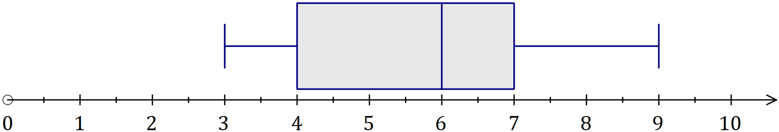
Solution
See graph
Specific behaviours
correctly locates five-number summary points (ft from a)
✓ draws box and whiskers

Question 3 (7 marks)
(a) The graph of $y=ax+b$ is shown below. Determine the values of $a$ and $b$. (2 marks)

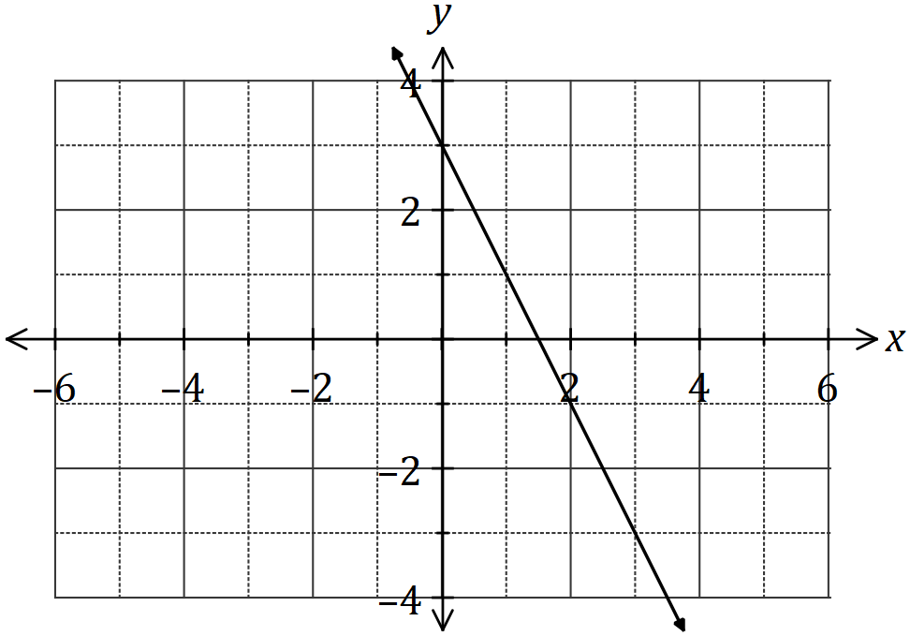
Solution
$$a=-2$$

$$b=3$$

Specific behaviours
correct value for $a$
✓ correct value for $b$

(b) Draw the graph of the line $y=\begin{matrix}1 \\ \overline{2}\end{matrix} x+2$ on the axes below. (3 marks)

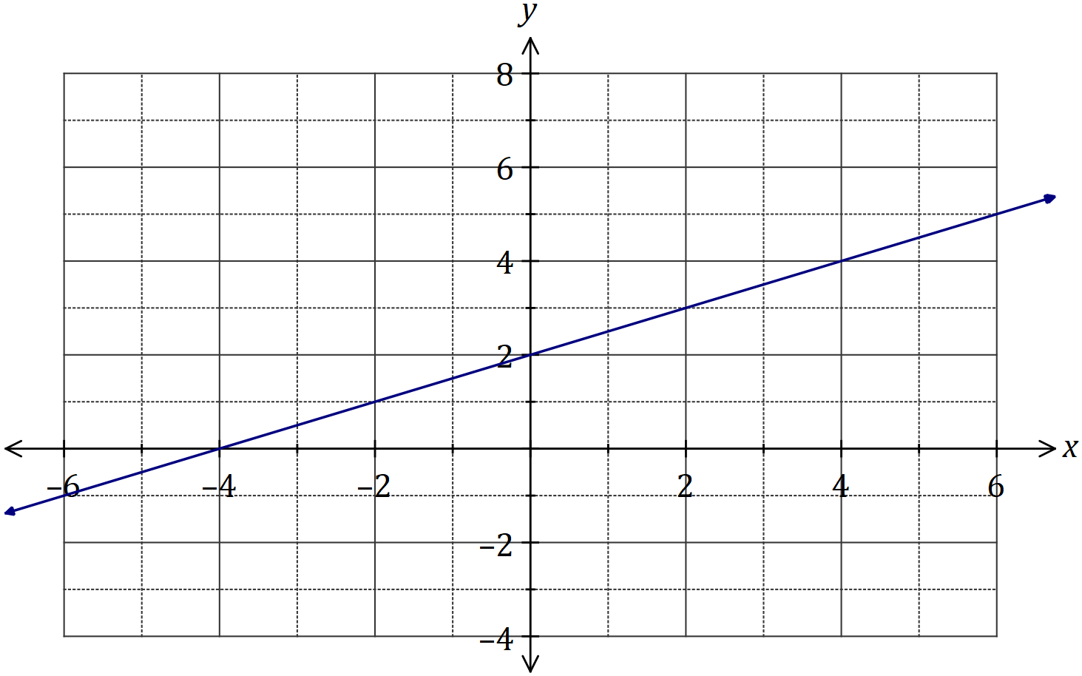
Solution
See graph
Specific behaviours
$y$-intercept
✓ $x$-intercept
✓ line drawn is straight

(c) Determine the gradient of the line $3x-2y=12$. (2 marks)
Solution
$$2y=3x-12$$
$$y=1.5x-6$$

$$\text{Gradient}=1.5$$

Specific behaviours
rearranges into $y=$ form
✓ states gradient

Question 4 (8 marks)
(a) The power $P$ consumed by a device can be calculated using the formula $P=I^{2}R+\sqrt{2R}$.

Calculate the value of $P$ when

(i) $I=5$ and $R=8$. (2 marks)
Solution
$$P=5^{2}×8+\sqrt{2×8} \\ P=25×8+\sqrt{16} \\ P=200+4=204$$

Specific behaviours
substitutes correctly, simplifying $I^{2}$ and $2R$
evaluates correctly

(ii) $I=0.5$ and $R=50$. (2 marks)
Solution
$$P={0.5}^{2}×50+\sqrt{2×50} \\ P=0.25×50+\sqrt{100} \\ P=12.5+10=22.5$$

Specific behaviours
substitutes correctly, simplifying $I^{2}$ and $2R$
evaluates correctly

(b) The variable $D$ is related to diameters $d_{1}, d_{2}$ and $d_{3}$ by the formula $D=\begin{matrix}d_{1} \\ \overline{ 4 }\end{matrix}+\begin{matrix}2 \\ \overline{d_{2}-d_{3}}\end{matrix}$.

Calculate the value of $D$ when

(i) $d_{1}=2$, $d_{2}=9$ and $d_{3}=1$. (2 marks)
Solution
$$D=\frac{2}{4}+\frac{2}{9-1}=\frac{2}{4}+\frac{2}{8} \\ D=\frac{2}{4}+\frac{1}{4}=\frac{3}{4}$$

Specific behaviours
substitutes correctly, simplifying $d_{2}-d_{3}$
evaluates correctly (anything equivalent)

(ii) $d_{1}=18$, $d_{2}=3.5$ and $d_{3}=4$. (2 marks)
Solution
$$D=\frac{18}{4}+\frac{2}{3.5-4}=\frac{18}{4}+\frac{2}{-0.5}$$
$$D=4.5-4=0.5$$

Specific behaviours
substitutes correctly, simplifying $d_{2}-d_{3}$
evaluates correctly

Question 5 (6 marks)
The graph below shows the cost $C$, in dollars, of taking a journey of $x$ km with a taxi company.

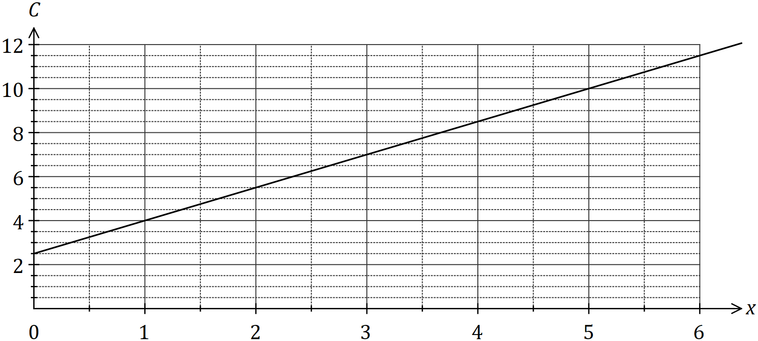

(a) State the cost of taking a $4 \text{km}$ journey. (1 mark)
Solution
$$\$8.50$$

Specific behaviours
correct cost

(b) How much more expensive is a $5 \text{km}$ journey compared to one of $4 \text{km}$? (1 mark)
Solution
$$10-8.50=\$1.50$$

Specific behaviours
correct difference

(c) State and interpret, in context, the value of the vertical axis intercept of the graph.
(2 marks)
Solution
$\$2.50$, a fixed cost payable regardless of distance travelled.

Specific behaviours
value, ✓ interprets as fixed cost, flag-fall, etc

(d) State and interpret, in context, the value of the gradient of the graph. (2 marks)
Solution
$m=1.5$, the cost per kilometre of a journey is $\$1.50$

Specific behaviours
value, ✓ interprets as cost per kilometre

Question 6 (6 marks)
The heights of $5$-year old boys are normally distributed with a mean of $109 \text{cm}$ and a standard deviation of $4 \text{cm}$.

(a) Use the $68\%, 95\%, 99.7\%$ rule to determine the approximate percentage of $5$-year old boys that can be expected to have heights between

(i) $97$ and $121 \text{cm}$. (2 marks)
Solution
$$109±12$$
$$±12÷4=±3 \text{sd's}⇒99.7\%$$

Specific behaviours
indicates $±3$ sd from mean
✓ correct percent (full marks if CAO)

(ii) $109$ and $113 \text{cm}$. (2 marks)
Solution
$$113-109=4$$
$$4÷4=1 \text{sd}⇒68÷2=34\%$$

Specific behaviours
indicates $1$ sd above mean
✓ correct percent (full marks if CAO)

(b) Nurses at a health clinic measure the heights of children and refer anyone with a height that is more than two standard deviations from the mean of the child's age group to a doctor.

The last eight boys, aged $5$, who attended the clinic had the following heights:

$$111 108 104 118 112 103 116 109 \text{cm}.$$

Determine, with justification, how many of these boys were referred. (2 marks)
Solution
Not referred if height between 101 and 117 cm.

So, one boy referred (118 cm).
Specific behaviours
correct number
✓ justification (eg standard score or states both bounds)

Question 7 (7 marks)
(a) The lines with equations $2y+2=x$ and $2y+x=-6$ are shown on the axes below.

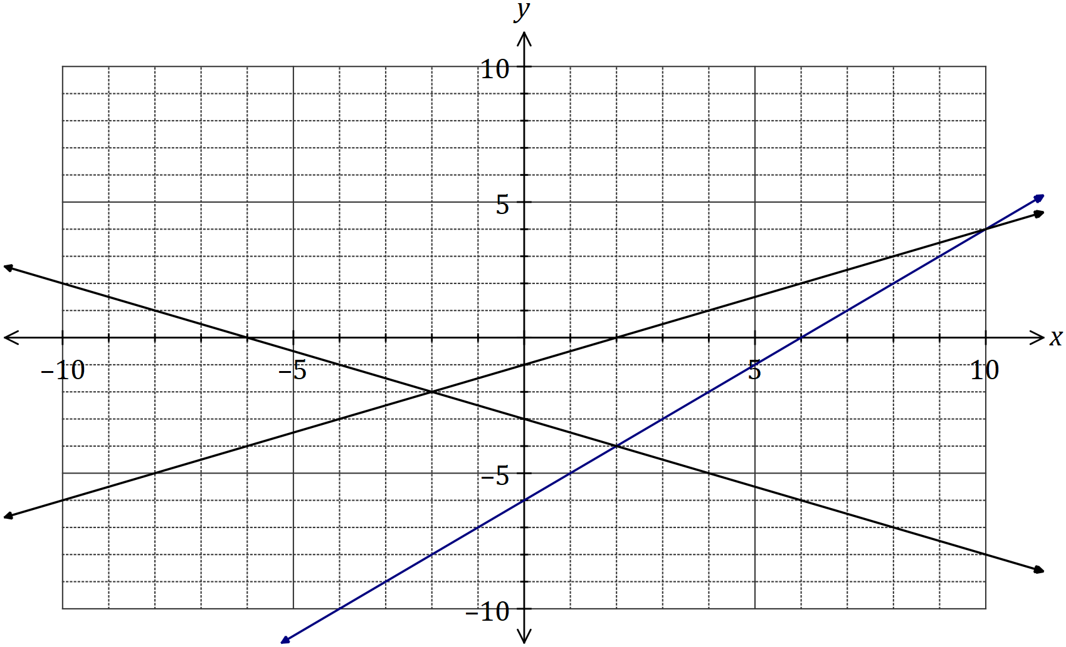
Solution
See graph
Specific behaviours
$y$-intercept
✓ $x$-intercept

(i) Draw the line $y=x-6$ on the axes above. (2 marks)

(ii) Show on the graph how to solve the simultaneous equations $y=x-6$ and
$2y+2=x$ and state the solutions.. (2 marks)
Solution
From graph, $x=10, y=4$

Specific behaviours
indicates with dashed lines on graph
✓ correct values of $x$ and $y$

(b) Solve the simultaneous equations $x+y=7$ and $2y+x=-6$. (3 marks)
Solution
$$\left(2y+x=-6\right)$$
$$-\left(x+y=7\right)$$

$$y=-13$$

$$x-13=7 \\ x=20$$

Specific behaviours
indicates use of substitution or elimination
✓ solves for $y$
✓ solves for $x$

Question 8 (8 marks)
A group of friends who frequently travelled abroad exchanged foreign currency between themselves using the conversion table below. For example, members of the group could exchange $100$ dollars for $20$ dinars or $50$ kroner for $10$ Australian dollars.

Country/Currency | Australian/Dollar
 | $$10$$ | $$20$$ | $$50$$ | $$100$$
Denmark/Kroner | $$50$$ | $$100$$ | $$250$$ | $$500$$
Japan/Yen | $$800$$ | $$1 600$$ | $$4 000$$ | $$8 000$$
Kuwait/Dinar | $$2$$ | $$4$$ | $$10$$ | $$20$$
Thailand/Baht | $$250$$ | $$500$$ | $$1 250$$ | $$2 500$$

(a) How many baht can be exchanged for $30$ Australian dollars? (1 mark)
Solution
$$\$30=\$20+\$10=500+250=750 \text{baht}$$

Specific behaviours
correct amount

(b) How many Australian dollars can be exchanged for $20 000$ yen? (2 marks)
Solution
$$20000=8000+8000+4000$$Dinars $=100+100+50$$$=250 \text{dollars}$$

Specific behaviours
appropriate method
correct amount

(c) Before travelling to Kuwait, one of the group exchanged $490$ Australian dollars for the local currency. How many dinars did they receive? (2 marks)
Solution
$$490=5×100-10 \\ =5×20-2 \\ =98 \text{dinars}$$

Specific behaviours
appropriate method
correct amount

(d) Another member of the group exchanged $500$ Australian dollars for a mixture of $1 350$ kroner and some yen. Determine the amount of Japanese currency they received.
(3 marks)
Solution
$$1350=500+500+250+100 \\ =\$100+\$100+\$50+\$20 \\ =\$270$$
$$\$500-\$270=\$230$$
$$\$230=\$100+\$100+\$20+\$10 \\ =8000+8000+1600+800 \\ =18 400 \text{yen}$$

Specific behaviours
converts kroner to dollars
calculates remaining dollars
converts dollars to yen

Supplementary page

Question number: _________

© 2018 WA Exam Papers. Kennedy Baptist College has a non-exclusive licence to copy and communicate this document for non-commercial, educational use within the school. No other copying, communication or use is permitted without the express written permission of WA Exam Papers. SN245-123-2.

